Software Requirements Specification

for

Artwork Sharing Platform, Release 1.0

Version 1.0 approved

Prepared by Group 6

Members include: Nguyen Hong Thinh (Leader), Trieu Quang Huy, Do Van Minh, Nguyen Ngoc Y Nhi, Nguyen Chan Ngoc Bao Tran

Process Impact

March 11, 2024

Table of Contents

Revision History ii

1. Introduction 1

1.1 Purpose 1

1.2 Document Conventions 3

1.3 Project Scope and Product Features 3

1.4 References 4

2. Overall Description 5

2.1 Product Perspective 5

2.2 User Classes and Characteristics 6

2.3 Operating Environment 6

2.4 Design and Implementation Constraints 6

2.5 Assumptions and Dependencies 6

3. System Features 7

4. Data Requirements 13

5. External Interface Requirements 10

6. Quality Attributes 18

Appendix A: Analysis Models 21

Revision History

|  |  |  |  |
| --- | --- | --- | --- |
| **Name** | **Date** | **Reason For Changes** | **Version** |
| Group 6 | 3/11/24 | initial draft | 1.0 draft 1 |

# Introduction

## Purpose

1. **Background:** Today there are many platforms to share works, but they may not focus on a specific market, many websites cannot guarantee the image quality of the works when posted on the platform, how to make money and how to make money. The guarantee of rights for creators and buyers is not clear or transparent.
2. **Business opportunity:** The global art market has evolved significantly, with a multitude of creators from diverse backgrounds seeking platforms to showcase and monetize their artworks. MyCremo, an innovative artwork sharing platform, addresses this need with a suite of features that sets it apart from existing platforms.

* **User-Friendly UX/UI Design:** Our system emphasizes a user-friendly UX/UI design that enhances the overall user experience. This improvement in interface design allows creators to present their portfolios in a manner akin to a job application, which can be directly sent to potential employers. This feature streamlines the job hunting process for artists and provides employers with an efficient way to discover new talents.
* **Artwork Interaction and Purchase:** MyCremo users can search, view, like, comment on, and add artworks to favorites, and even purchase artworks. This combination of social media and marketplace functionalities provides a comprehensive experience for both creators and buyers.
* **Globalization Approach:** We plan to integrate multi-language support and currency conversion systems, catering to various countries. This global approach benefits artists by enabling cross-border connections and job opportunities, thereby enhancing cultural exchange and diversity in the art community.
* **Preferential Policies for Active Creators:** We intend to introduce policies like reduced commission rates, featured spots on the platform, or access to exclusive tools and analytics. These incentives encourage diverse contributions from creators, leading to a richer community.
* **Financial Empowerment of Creators:** MyCremo aims to improve the financial prospects of creators through competitive pricing tools, access to a broader range of buyers, and opportunities for collaboration and sponsorship. This focus on financial empowerment helps artists sustainably pursue their passion.
* **Moderation and System Management:** With features for managing posts, users, and the overall system, MyCremo ensures a safe and respectful online environment.
* **Creator Autonomy and Engagement:** Creators on MyCremo can manage their artworks and interact with the community, enhancing their engagement and visibility.
* **Recommendation System:** The platform's recommendation system personalizes the user experience, helping users discover new artists and pieces.
* In essence, MyCremo is more than just a marketplace; it's a comprehensive ecosystem designed to foster the growth and prosperity of the global artist community. Through its user-centric design, global reach, supportive policies, and focus on financial empowerment, MyCremo aims to revolutionize the way artists share, monetize, and thrive in their creative endeavors. By addressing the unique needs of the art community, MyCremo positions itself as a key player in the evolving global art market.

1. **Business Objectives:**

* BO-1: Enhance User Engagement

Scale: Number of active users and user interactions on the platform.

Meter: User engagement analytics and platform activity logs.

Goal: Increase user engagement by 30% within 6 months following the initial release.

Stretch: Achieve a user engagement increase of 50%.

* BO-2: Expand Artwork Diversity

Scale: Number of unique artworks and artists featured on the platform.

Meter: Artwork database and artist registration statistics.

Goal: Increase the diversity of artworks by 20% within 9 months following the initial release.

Stretch: Achieve a 30% increase in artwork diversity.

* BO-3: Facilitate Artist Collaboration

Scale: Number of collaborative projects and partnerships between artists.

Meter: Collaboration logs and partnership success metrics.

Goal: Foster artist collaboration and achieve a 25% increase in collaborative projects within 12 months following the initial release.

Stretch: Achieve a 40% increase in artist collaboration.

* BO-4: Ensure Platform Security and Integrity

Scale: Number of reported security incidents and data integrity checks.

Meter: Security incident reports and integrity audit logs.

Goal: Maintain a secure platform with no major security incidents and ensure data integrity.

Stretch: Achieve a 10% reduction in reported incidents over the first year.

* BO-5: Monetization and Sustainability

Scale: Revenue generated from premium features, partnerships, and sponsorships.

Meter: Financial reports and revenue analytics.

Goal: Achieve sustainable monetization with a 15% increase in revenue within 12 months following the initial release.

Stretch: Attain a 25% increase in overall revenue streams.

* These Business Objectives aim to drive the success and growth of the Artworks Sharing Platform by focusing on user engagement, diversity of artworks, artist collaboration, platform security, and financial sustainability. The specific metrics and goals provide a measurable framework for assessing the platform's performance and progress over time.

1. **Vision Statement:**

For creators who want to easily showcase and monetize their artwork worldwide, the Artwork Sharing Platform is a website and mobile app that will allow them to upload images of their creations to display in an online portfolio and offer available works for sale. Unlike traditional galleries, artists who use the Cremo platform will not need to find venues to exhibit or handle financial transactions, which will save them time and make selling more accessible.

For art enthusiasts, the Artwork Sharing Platform is a website and mobile app that opens up unlimited access for them to browse and discover diverse, high-quality art pieces from rising talents and renowned artists around the world. Unlike mainstream galleries, art lovers who use Cremo platform will be able to easily find art tailored to their personal taste and style with our personalized recommendations and browsing tools. Our secure e-commerce system also makes purchasing art a seamless, transparent experience for enthusiasts compared to traditional methods.

## Document Conventions

No special typographical conventions are used in this SRS.

## Project Scope and Product Features

1. **Major Features**

FE-1: Artwork Discovery and Interaction

* Search and discover artwork by genre or keyword
* View artwork details and images
* Purchase premium artwork
* Interact with artwork by liking and commenting
* Propose artistic services for specific creators
* Follow favorite creators

FE-2: Creator Tools

* Publish artwork for others to view
* Sell artwork directly on the platform
* Manage artwork portfolios and listings
* Respond to inquiries and requests from users
* Open artistic services upon request

FE-3: Content Moderation

* Monitor and moderate user-generated content
* Handle complaints and disputes on the platform
* Ensure compliance with community guidelines and policies

FE-4: Transaction and Payment

* View available artworks for purchase
* Perform secure and secure payments on the platform
* Track transaction history and orders
* Accept payments from various methods
* Provide shopping cart and order functionalities

FE-5: Social Features

* Share favorite artworks with the community
* Participate in discussions and groups about art
* Follow and receive notifications about activities of other users
* Interact with other artists and fans through chat and comments

FE-6: Personalization

* Customize personal profiles and pages
* Manage watchlists and personal notifications
* Create and manage favorite lists and personal collections

FE-7: Customer Support

* Provide support and assistance to users
* Resolve technical and payment-related issues
* Assist with platform usage and features

1. **Scope of Initial and Subsequent Releases**

|  |  |  |  |
| --- | --- | --- | --- |
| Feature | Release 1 | Release 2 | Release 3 |
| FE-1, Artwork Discovery | Search and view artwork; purchase premium artwork; interact with artwork | Propose artistic services upon request for creators | Follow favorite creators |
| FE-2, Creator Tools | Publish artwork for others to view; sell artwork; manage portfolios | Respond to inquiries and requests from users | Open artistic services upon request |
| FE-3, Content Moderation | Monitor and moderate user-generated content | Handle complaints and disputes on the platform | Ensure compliance with community guidelines and policies |
| FE-4, Transaction and Payment | View available artworks for purchase; perform secure payments; track transaction history | Accept payments from various methods; provide shopping cart | Provide order functionalities |
| FE-5, Social Features | Share artwork; participate in discussions; follow users | Receive notifications about activities; interact with artists | Create groups and participate in artist community |
| FE-6, Personalization | Customize profiles and pages; manage watchlists and notifications | Create and manage favorite lists and collections | Set preferences and settings for best user experience |
| FE-7, Customer Support | Provide assistance to users; resolve technical issues | Assist with platform usage and features; resolve payment issues | Provide platform usage and feature support |

1. **Limitations and Exclusions**

LI-1:

* The platform will offer a curated selection of artwork, focusing on quality and relevance to the audience.
* Some features or interactions may be limited based on the nature of the artwork and creator preferences.

LI-2:

* The platform will be accessible to users worldwide but may have limitations or restrictions in certain regions due to legal or logistical reasons.
* Access to certain features may be restricted based on user permissions or account types.

## References

References to relevant documents are provided:

* COS SRS
* COS Vision and Scope
* COS Business Rule
* COS Usecase

Retrieve from: https://lms-hcmuni.fpt.edu.vn/mod/resource/view.php?id=2435

# Overall Description

## Product Perspective

The Artwork Sharing Platform is a revolutionary software system designed to transform the way artists showcase and sell their artwork online. This platform replaces traditional methods of art promotion and sales, offering a seamless and efficient solution for creators and art enthusiasts alike.

Similar to the context diagram depicted in Figure 1 for the Artwork Sharing Platform interfaces with various external entities to facilitate its functionalities. Initially, the platform enables users to upload, view, and purchase artwork directly from creators. As the platform evolves through subsequent releases, it will integrate with Internet ordering services for additional features, such as facilitating transactions with local art galleries and enabling secure payment processing through various methods including credit and debit cards.

The envisioned system aims to provide a comprehensive solution for artists and art lovers, streamlining the process of discovering, purchasing, and promoting artwork in the digital age.

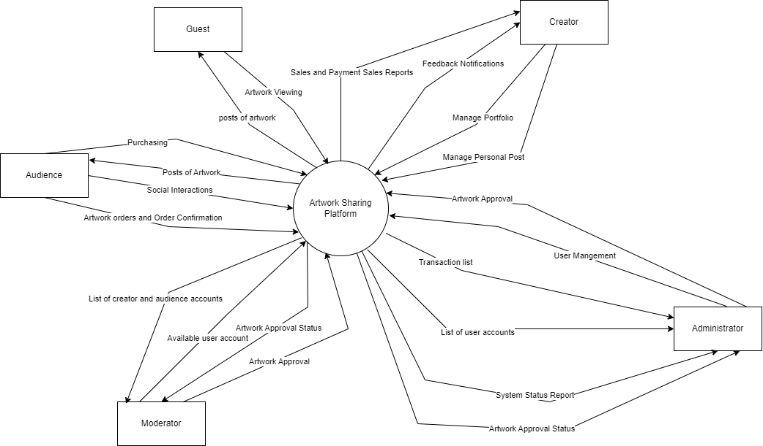

Figure 1. Context diagram for release 1.0 of the Artwork Sharing Platform.

## User Classes and Characteristics

**Guests:**

Guests can freely browse the website and view artworks without logging in. However, they cannot purchase artworks or participate in discussions.

**Creators:**

Creators can post and manage their own artworks. They can edit artwork details, prices, or delete artworks anytime. Creators have their own profile to showcase artworks and artist information. They can interact with fans by commenting, liking, and following. Creators can chat with customers to discuss art pricing and sales. They can also chat with admin regarding content issues. Creators have access to sales statistics and analytics. They can sell art across multiple platforms/channels beyond just the website.

**Art Enthusiasts:**

Enthusiasts can view, review, rate, and comment on artworks. They can follow their favorite artists for update notifications. Enthusiasts can further engage by logging in - liking, commenting, chatting with creators, and purchasing artworks. They can create personal collections, share artworks, and get recommendations based on preferences. Enthusiasts have advanced search and filtering capabilities.

**Admin:**

Administrators moderate content on the platform by reviewing submissions and enforcing policies. They can comment on artworks and feature them. Admins manage user accounts and permissions. They have the capability to delete violating content or users.

## Operating Environment

OE-1: The Artwork Sharing Platform shall function seamlessly with the following web browsers: Windows Internet Explorer versions 7, 8, and 9; Firefox versions 12 through 26; Google Chrome (all versions); and Apple Safari versions 4.0 through 8.0.

OE-2: The Artwork Sharing Platform shall support access from various devices, including desktop computers, laptops, smartphones, and tablets.

## Design and Implementation Constraints

CO-1: The system must support multi-device platforms, including desktops, laptops, smartphones and tablets running on popular operating systems such as Windows, macOS, Android and iOS.

CO-2: All user interfaces must be designed to be compatible with different screen sizes and provide a smooth user experience on mobile devices and computers.

CO-3: The system must support multimedia interactivity, including images, video, and audio, to enhance the user experience when browsing and interacting with artwork.

## Assumptions and Dependencies

AS-1: The Artwork Sharing Platform operates 24/7, providing continuous access to users at all times.

AS-2: All user interactions and transactions on the platform are securely encrypted to protect sensitive information and ensure user privacy.

AS-3: Every user account on the platform must undergo verification and identity authentication to ensure security and credibility within the user community.

DE-1: The operation of the Artwork Sharing Platform is contingent upon the active participation of creators, as the platform's content and value rely on their contributions.

DE-2: The system's functionality depends on integration with secure authentication and verification services, such as session management systems, to safeguard user data and prevent unauthorized access.

# System Features

**Figure 3.1: Usecase Diagram**

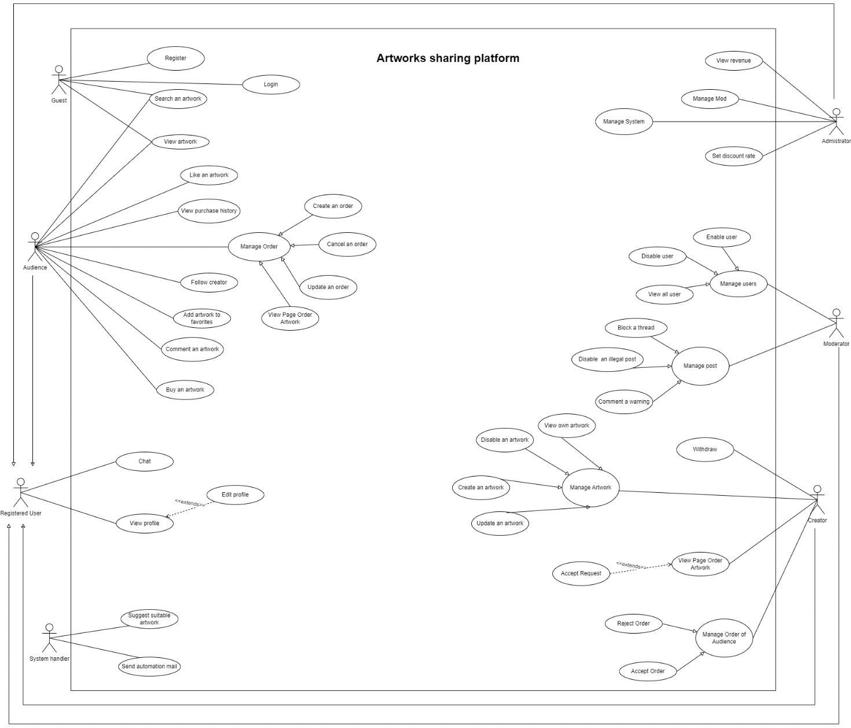

|  |  |  |  |
| --- | --- | --- | --- |
| Id and Name | **UC-1 Login** | | |
| Created By: | Hồng Thịnh | Date Created: | 21/1/24 |
| Primary Actor: | Audience | Secondary Actors: | Google,Facebook |
| Description: | Users enter login information including email/login name and password to access personal accounts on the system.The system will check whether the login information is valid or not. If valid, the user will be taken to the home page that matches their permissions. | | |
| Trigger: | The user accesses the system's login page | | |
| Preconditions: | PRE-1. The user already has an account on the system PRE-2. The system is operating normally, without technical problems PRE-3 Users have access devices and stable internet connection | | |
| Postconditions: | In case of successful login:  POST-1: The user is granted access to his account POST-2: Users are redirected to the interface appropriate to their permissions POST-3: User login and session information are saved on the system  In case of unsuccessful login:  POST-1: The system does not grant account access rights POST-2: The system may record incorrect login information POST-3: The number of failed login attempts can be limited | | |
| Normal Flow: | 1.The user accesses the system login page 2.The system displays a login form asking to enter email/username and password 3.User enters login information 4.The system checks the validity of the entered information 5.The system verifies correct login information 6.The system grants account access rights to users 7.The system redirects users to the interface corresponding to their permissions | | |
| Alternative Flows: | 1.User forgot password -User clicks on "Forgot password" -The system requires the user to enter their registered email -The system sends a confirmation email and resets a new password to the user -The user enters a new password and logs back into the system  2.User login by google or facebook -On the login interface, the user clicks on the "Sign in with Google" or "Sign in with Facebook" button -The system redirects users to the Google/Facebook authentication page -User enters Google/Facebook account information for authentication -Google/Facebook validates the information and redirects back to the website -The system automatically creates new accounts for users based on information from Google/Facebook -The system redirects users to the interface corresponding to their permissions. | | |
| Exceptions: | Exceptions:  1. Login information is incorrect: -The system reports a failed login error -Allow re-entering login information -After 3 incorrect entries, the system locks the account within 1 hour 2. System crashes: -Display system error message -Record and send error reports to admin -Ask the user to try again later 3. Account locked due to incorrect input too many times: -Display message about account being locked -Guide users through the steps to unlock their accounts | | |
| Priority: | required | | |
| Frequency of Use: | Login is a basic function, used frequently by all users,they need to log in to start using other functions of the system.Frequency of use depends on the type of application, it can be several times/day or several times/week. For employees, the average login frequency is 2 times/day. For customers, the average login frequency is 1 time/week. | | |
| Business Rules: | -Username must be a valid email address -Password must be at least 8 characters long, including letters and numbers -After 5 incorrect login attempts, the account will be locked within 1 hour. -The login session will expire after 20 minutes of inactivity. | | |
| Other Information: | -Users can retrieve their password by using the "Forgot password" function on the login screen. The system will send a password reset link via registered email.  -Integrating login via social networks (Facebook, Google) makes it convenient for users  -Security measures: Captcha, 2-factor authentication, account lock after 5 incorrect entries,... help limit unauthorized access. | | |
| Assumptions: | -The user already has a valid account and password on the system. -Users can access the internet stably to use the login function. -The system has a database that stores user registration and login information. -Security measures, attack prevention, and unauthorized access have been implemented. | | |
| Id and Name | **UC-2 Buy an artwork** | | |
| Created By: | Bảo Trân | Date Created: | 21/1/24 |
| Primary Actor: | Audience | Secondary Actors: | An artwork |
| Description: | Actor must be login with role audience and search artwork successfully and then choose artwork need buy. If buy successfully then the system will send message "Buy successfully" and send timeline delivery time else the system will message "Buy fail" | | |
| Trigger: | creator received purchase notification from audience | | |
| Preconditions: | PRE-1. The user already has an account with role audience in the system PRE-2. The artwork must be valid | | |
| Postconditions: | In case of successful buy:  POST-1: The user must be login POST-2: Choose any artwork and click buy it POST-3: System send message "Successfully"  In case of unsuccessful buy:  POST-1: The system send message "Error system / payment unsuccessfully ..." POST-2 The system rollback page pay  POST-3 The user cacel order | | |
| Normal Flow: | 1.The user login with role audience 2.The system displays a home page  3.The user choose artwork or search  4.The system will display artwork if user search  5.The user choose any artwork want to buy 6.The system will switches to payment page 7.The user choose payment method 8.The user click buy or finish  9.The user cancel order | | |
| Alternative Flows: | 1.The system confirm role user 2.The system will respone list artwork if user search 3.The system check artwork valid or invalid  4.When user click buy , the system will check both quantity and artwork valid 5.When user choose checkout, system will switches to payment page 6.The user choose payment method suitable (VISA/COD/NAPAS..) 7.The user click pay artwork 8.The system will save order. 9.The system check order when user cancel, the system will refund if check all successfully | | |
| Exceptions: | 1.Product invalid 2.Quantity not enough when many buyer at the same time 3.Payment method error such connect 4.User cancel order | | |
| Priority: | High | | |
| Frequency of Use: | Depend on audience's behavior | | |
| Business Rules: | BR1- Actor must have account with role audience BR2- Artwork be choose must be valid and only buy 1 artwork at the same time  BR3- Must choose a payment method (VISA, e-Banking, e-wallet). - Every creator can have 3 payment method (VISA, e-Banking, e-wallet). | | |
| Other Information: | -The audience can choose between many payment methods (VISA/ NAPAS/ COD) | | |
| Assumptions: | -The user MUST be login successfully -Users can access the internet stably to **buy** artwork function. -The system has a database that stores order of user. -Security measures, attack prevention, and unauthorized access have been implemented. | | |
| Id and Name | **UC-3 Withdraw balance** | | |
| Created By: | Huy Trieu | Date Created: | 22/1/24 |
| Primary Actor: | Creator | Secondary Actors: | An artwork |
| Description: | - Creator login successfully with creator account to withdraw their balance. | | |
| Trigger: | Creator received notification mail successfully. | | |
| Preconditions: | PRE-1. The user already has an account with role creator in the system. PRE-2. The creator can view balance of their account. PRE-3. Creator updated payment method in their account. PRE-4. Creator have enough balance. | | |
| Postconditions: | In case of successful: POST-1: Creator login successfully. POST-2: Balance must be enought to withdrawal POST-3: System send toast message "Successfully" and send email notificaltion.  In case of unsuccessful: POST-1: The system send toast message "Error system / payment unsuccessfully ..." POST-2 The system rollback page pay | | |
| Normal Flow: | 1. User have creator account and login to system. 2. User click on tab button withdrawal. 3.The system navigation to withdrawal page. 4. Creator update payment method ( if they dont have) 5. Creator choose payment method. 6. Creator input balance want to withdrawal. Balance must be less or equal with available balance. 7. Creator click on confirm button to process withdrawal. For successfully case. 8.1. Toast message to notify transaction successfullly "Withdrawal sucessfully". 9.1 Update available balance of creator. 10.1. Send email for creator. For failue case. 8.2 Toast message to notify transaction error "Some thing wrong". | | |
| Alternative Flows: | TBD | | |
| Exceptions: | Exceptions:  1.Withdrawl: - Error at payment step. - Invalid payment method. - Networking error. | | |
| Priority: | High | | |
| Frequency of Use: | Depend on audience's behavior | | |
| Business Rules: | - Creator can withdrawal all of available balances. - Every withdrawal transaction should be logged with relevant details, including the user, amount, timestamp, and any additional information. - When withdrawal failue by network or error in system the creates available balances must rollback to creator account. - Creator must be notify about transaction withdrawal successfully in email. - Message must be toast message. |  |  |
| Other Information: | -The audience can choose between many payment methods | | |
| Assumptions: | -The user MUST be login successfully -Users can access the internet stably to **withdrawal**. -The system has a database that stores order of user. -Security measures, attack prevention, and unauthorized access have been implemented. | | |
| ID and Name: | **UC-04 Register** | | |
| Created By: | Do Van Minh | Date Created: | 22/1/2024 |
| Primary Actor: | Guest | Secondary Actors: | Artwork Sharing Platform |
| Description: | Guests sign up to a new account to access the system's resources by accessing the Artwork Sharing Platform from online devices. | | |
| Trigger: | Guest want to create new account in the Artwork Sharing Platform | | |
| Preconditions: | PRE-1. Guest access to the Register page. PRE-2. Guest must fill all the information in the sign up form | | |
| Postconditions: | POST-1. The notification shows “Create account successful ”. POST-2. Registered users become Audience and can modify their own account profile. | | |
| Normal Flow: | 1.0 Register new account 1.1 Guest access to register page 1.2 The system displays a register form including name, email, phone,… 1.3 Guest filled all information correctly 1.4 System Validate 1.5 Guest submitted the form by clicking the “register new account” button 1.6 Artwork Sharing Systems transferring user back to home page | | |
| Alternative Flows: | none | | |
| Exceptions: | 1.0. Invalid Input Format  1.1. If the user enters information in an invalid format (e.g., incorrect email format), display an error message indicating the specific input error.  1.2. Prompt the user incorrect format  2.0. Account is already exited  2.1. If the input account already remained in database, display a message”The account already sign up, please sign in”  2.2 Transfer user back to login page  3.0. Email is already exited  3.1. If the input Email already remained in database, display a message”The Email already sign up”  4.0 Password incorrect:  4.1 Error message asking to re-enter password  4.2 Check if the re-entered password matches | | |
| Priority: | Medium | | |
| Frequency of Use: | Approximately 300 users, average of one usage per day. Peak usage load for this use case is between 9:00 A.M. and 10:00 A.M. local time. | | |
| Other information | 1. Implement validation checks to ensure that the entered information is accurate and meets specified criteria. | | |
| Business Rules: | **1. Unique Email/Usernames: Users must register with a unique email address or username to ensure distinct user accounts. 2. Confirmation : Users are required to confirm their password during the registration process to activate their accounts.** | | |
| Assumptions: | Assume that 150 Guests will sign up the Artwork Sharing System a day | | |
| Id and Name | **UC-5 Like an artwork** | | |
| Created By: | Y Nhi | Date Created: | 21/1/24 |
| Primary Actor: | Audience | Secondary Actors: | Artwork Sharing Platform |
| Description: | User who wish to express their appreciation for an artwork can 'like' the artwork. Each 'like' will be recorded in the Artwork Database, which may affect the artwork's popularity and visibility on the platform | | |
| Trigger: | User clicks on the 'like' button of an artwork. | | |
| Preconditions: | PRE-1. User is logged into the platform. PRE-2. Artwork is available for interaction. | | |
| Postconditions: | POST-1. Artwork's like count is incremented by one. POST-2. User's like is recorded in their profile. | | |
| Normal Flow: | **1.0 Like an Artwork** 1.User navigates to an artwork. 2. User clicks the 'like' button associated with the artwork. 3. The platform checks if the User has already liked the artwork. 4. If not, the platform increments the artwork's like count. 5. The platform updates the Artwork Database to record the new like. 6. The platform updates the User's profile to include the liked artwork. 7. The platform provides visual confirmation to the User that the artwork has been liked. | | |
| Alternative Flows: | **A1. User attempts to like an artwork they have already liked** - The platform reduces likes of associated artwork - The interface resets to the state when the artwork has not been liked - Show the message "Unliked [title of artwork]"- If the user tries to like again, perform the normal flow again | | |
| Exceptions: | 1.0.E1 User is not logged in and tries to like an artwork 1.0.E2 Artwork is not available or has been removed | | |
| Priority: | Medium | | |
| Frequency of Use: | Depend on User's behavior | | |
| Business Rules: | BR-1 User must be logged in to like an artwork. BR-2 Each User can only like an artwork once. | | |
| Other Information: | -User likes may influence the artwork's ranking and visibility on the platform. | | |
| Assumptions: | -The artwork sharing platform has a reliable and scalable Artwork Database that can handle multiple simultaneous 'like' actions without any loss of data. -Users understand the meaning of 'liking' an artwork and the impact it has on the artwork's visibility and popularity within the platform. -There is a system in place to authenticate users and ensure that only logged-in users can like an artwork. -The platform supports real-time updates so that when a user likes an artwork, the like count is immediately reflected and visible to all users. | | |

# Data Requirements

## Logical Data Model

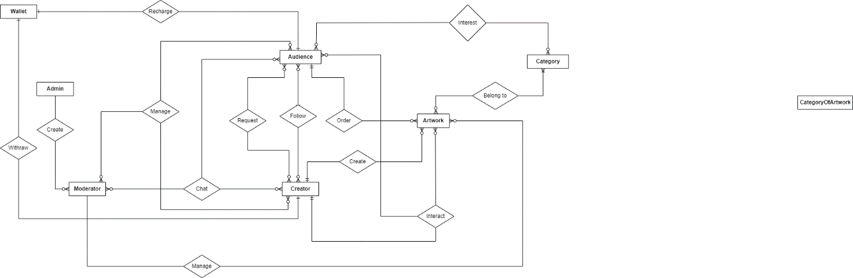

Figure 4.1. Partial data model for release 1.0 of the Artwork Sharing Platform.

## Data Dictionary

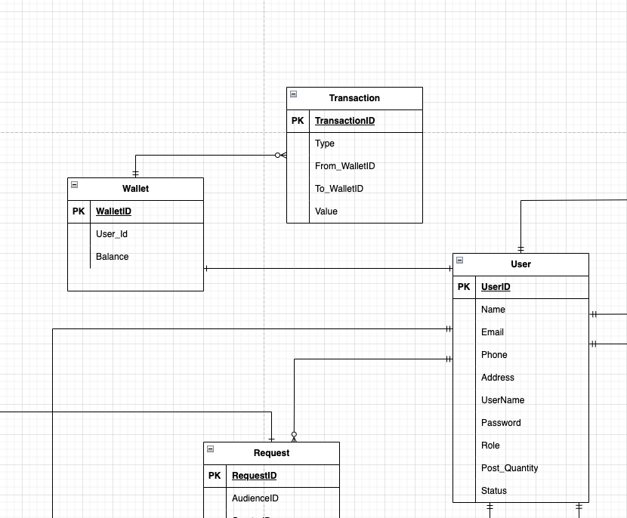

TABLE: TRANSACTION

|  |  |  |  |  |  |  |
| --- | --- | --- | --- | --- | --- | --- |
| **No** | **Field Name** | **Type** | **Unique** | **Not Null** | **FK/PK** | **Note** |
| 1 | TransactionID | uuid | x | x | FK |  |
| 2 | Type | string |  | x |  | Has enum value |
| 3 | From_WalletID | uuid |  | x | PK |  |
| 4 | To_WalletID | uuid |  | x | PK |  |
| 5 | Value | number |  | x |  |  |
| 6 | CreatedAt | timestamp(3) |  | x |  |  |

TABLE: WALLET

|  |  |  |  |  |  |  |
| --- | --- | --- | --- | --- | --- | --- |
| **No** | **Field Name** | **Type** | **Unique** | **Not Null** | **FK/PK** | **Note** |
| 1 | WalletID | uuid | x | x | FK/PK |  |
| 2 | User_Id | uuid |  | x | PK |  |
| 3 | Balance | number |  | x |  |  |
| 4 | CreatedAt | timestamp(3) |  | x |  |  |
| 5 | UpdatedAt | timestamp(3) |  |  |  |  |

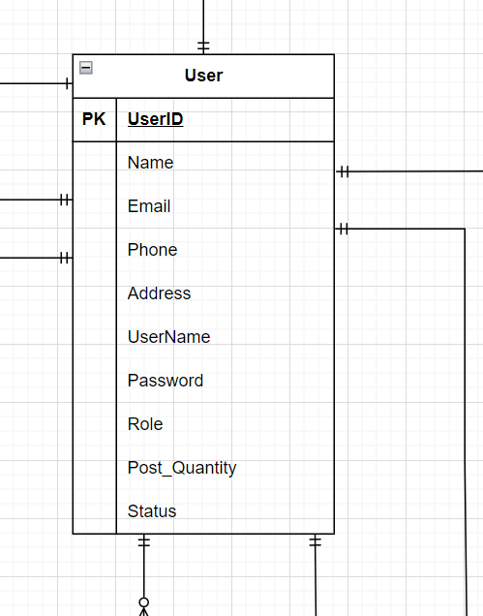

TABLE: USER

|  |  |  |  |  |  |  |
| --- | --- | --- | --- | --- | --- | --- |
| No | Field Name | Type | Unique | Not null | FK/PK | Note |
| 1 | UserID | string |  | X | PK |  |
| 2 | Name | string |  | X |  |  |
| 3 | Email | string | X | X |  |  |
| 4 | Phone | string |  |  |  |  |
| 5 | Address | string |  | X |  |  |
| 6 | UserName | string |  | X |  |  |
| 7 | Password | string |  | X |  |  |
| 8 | Role | string |  | X |  |  |
| 9 | Post_Quantity | int |  |  |  |  |
| 10 | Status | string |  | X |  |  |
| 11 | CreatedAt | timestamp(3) |  |  |  |  |

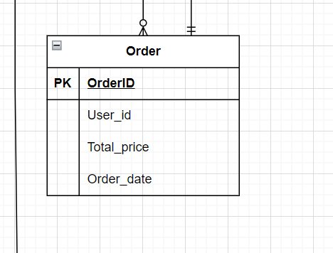

TABLE: ORDER

|  |  |  |  |  |  |  |
| --- | --- | --- | --- | --- | --- | --- |
| No | Field Name | Type | Unique | Not null | FK/PK | Note |
| 1 | OrderID | string |  | x | PK |  |
| 2 | userID | string |  | x | FK |  |
| 3 | Total_price | float |  | x |  |  |
| 4 | order_date | date |  | x |  |  |
| 5 | CreatedAt | timestamp(3) |  |  |  |  |
| 6 | UpdatedAt | timestamp(3) |  |  |  |  |

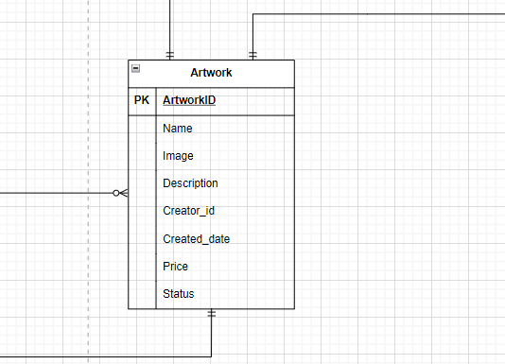

TABLE : ARTWORK

|  |  |  |  |  |  |  |
| --- | --- | --- | --- | --- | --- | --- |
| No | Field Name | Type | Unique | Not null | FK/PK | Note |
| 1 | ArtworkID | int | x | x | PK |  |
| 2 | Image | file | x | x |  |  |
| 3 | Description | string |  | x |  |  |
| 4 | creator_id | string |  | x | FK |  |
| 5 | create_date | date |  | x |  |  |
| 6 | price | float |  |  |  |  |
| 7 | status | string |  | x |  |  |
| 8 | UpdatedAt | timestamp(3) |  |  |  |  |

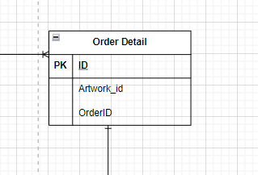

TABLE: ORDER DETAIL

|  |  |  |  |  |  |  |
| --- | --- | --- | --- | --- | --- | --- |
| No | Field Name | Type | Unique | Not null | FK/PK | Note |
| 1 | ID | string |  | x | PK |  |
| 2 | Artwork_id | int |  | x | FK |  |
| 3 | order_id | string |  | x | FK |  |
| 4 | UpdatedAt | timestamp(3) |  |  |  |  |

# 5. External Interface Requirements

## 5.1 User Interfaces

UI-1: The Artwork Sharing Platform screens shall adhere to the User Interface Design Guidelines, ensuring ease of use and intuitive navigation for both users and creators.

UI-2: Audience can easily view works and find the creator easily when wanting to buy works. Creator can easily post and sell works to reach viewers Easy search and discovery: 99% of the platform's users can easily search for products and share artwork

UI-3: The platform shall support keyboard navigation, allowing users to browse and interact with artwork using keyboard commands alongside mouse interactions.

## 5.2 Software Interfaces

SI-2: Payment System

The platform shall interface with the Payment System to handle transactions securely and efficiently, catering to both users and creators:

SI-2.1: Facilitating payment transactions for purchasing artworks and accessing premium features.

SI-2.2: Verifying payment status, transaction details, and managing refunds or cancellations as necessary.

## 5.3 Hardware Interfaces

No hardware interfaces have been identified.

## 5.4 Communications Interfaces

CI-1: The platform shall send email or text message notifications to users and creators to confirm orders, payment receipts.

CI-2: Email or text message notifications shall also be sent to report any issues or discrepancies related to artwork orders, payments, or content moderation on the platform.

# Quality Attributes

## Reliability Requirements

REL-1: The Artwork Sharing Platform (ASP) shall ensure that uploaded artworks are stored securely and remain accessible without data loss or corruption with a reliability rate of 99.9%.

REL-2: The ASP shall maintain a backup of all user data, including artwork uploads and user profiles, with a backup frequency of at least once per day. The backup system shall be capable of restoring data within 24 hours in case of data loss or system failure.

REL-3: The ASP shall have a failover mechanism in place to switch to backup servers automatically in the event of a server failure, ensuring continuous availability of the platform with minimal downtime. The failover process shall occur within 5 minutes of detecting a server failure.

REL-4: The ASP shall implement user authentication and authorization mechanisms to prevent unauthorized access to sensitive user data and ensure the integrity of the platform's functionalities.

REL-5: The ASP shall monitor system performance and resource utilization continuously, with automated alerts configured to notify administrators of any anomalies or potential issues. The monitoring system shall be capable of detecting and resolving performance issues proactively to maintain the reliability of the platform.

REL-6: The ASP shall provide users with real-time notifications and status updates regarding the availability and performance of the platform, ensuring transparency and trustworthiness in its reliability.

## Performance Requirements

PER-1: Website Load Time: No individual page's load time exceeds the 2-second threshold for broadband connections or the 5-second threshold for 3G connections in more than 5% of all measured instances.

PER-2: Server response time: The response time calculated by the time taken from sending a request to the server to receiving the first byte of the response (Time to First Byte - TTFB), shall not exceed 500 milliseconds (ms) for 95% of all requests under normal operating conditions.

## Security Requirements

SEC-1: User data is safeguarded with encryption within the database, accessible solely through authorized access tokens.

SEC-2: Every user is required to authenticate themselves on Cremo for all interactions, with the exception of browsing artwork and accessing creator details.

SEC-3: Data management responsibilities, including content moderation, user oversight, and post evaluation, are exclusively entrusted to authorized moderators and administrators.

SEC-4: Audience members can view and track the progress of their own orders. Creators can only view and manage their own orders. Admins have the authority to monitor all transactions and detect any anomalies.

## Safety Requirements

SAF-1: The platform shall implement age-appropriate content filtering mechanisms to ensure that users, particularly minors, are not exposed to inappropriate or explicit artwork content, thereby promoting a safe and secure browsing environment.

## Availability Requirements

AVL-1: The project shall be available at least 60% ,excluding scheduled maintenance windows

AVL-2: Multi-Device Support: The platform must be compatible and operate smoothly across different devices including smartphones, tablets, and desktop computers, ensuring users can access artwork anytime, anywhere.

AVL-3: Data Backup and Recovery: Automatic data backups should occur daily, with the ability to perform additional backups before major updates. The platform must support rapid data recovery to minimize downtime in the event of data loss.

# Appendix A: Analysis Models

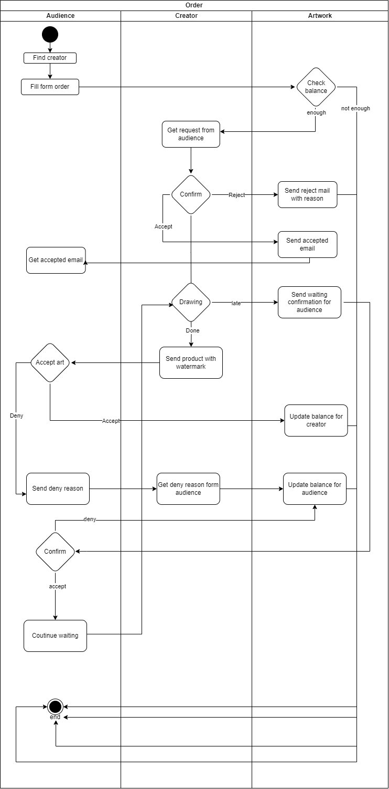**Figure 1. is a swimlane model that describes the process of setting up an order painting information system**

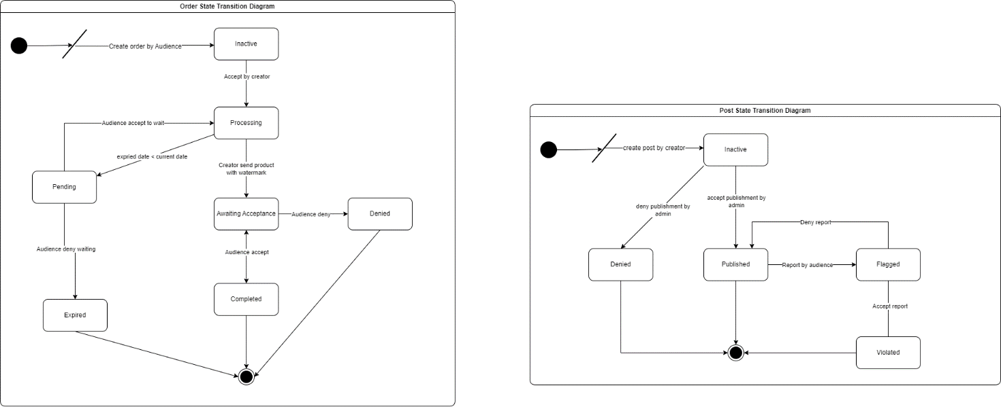

Figure 2. State-transition diagram for artwork order status and post artwork status.

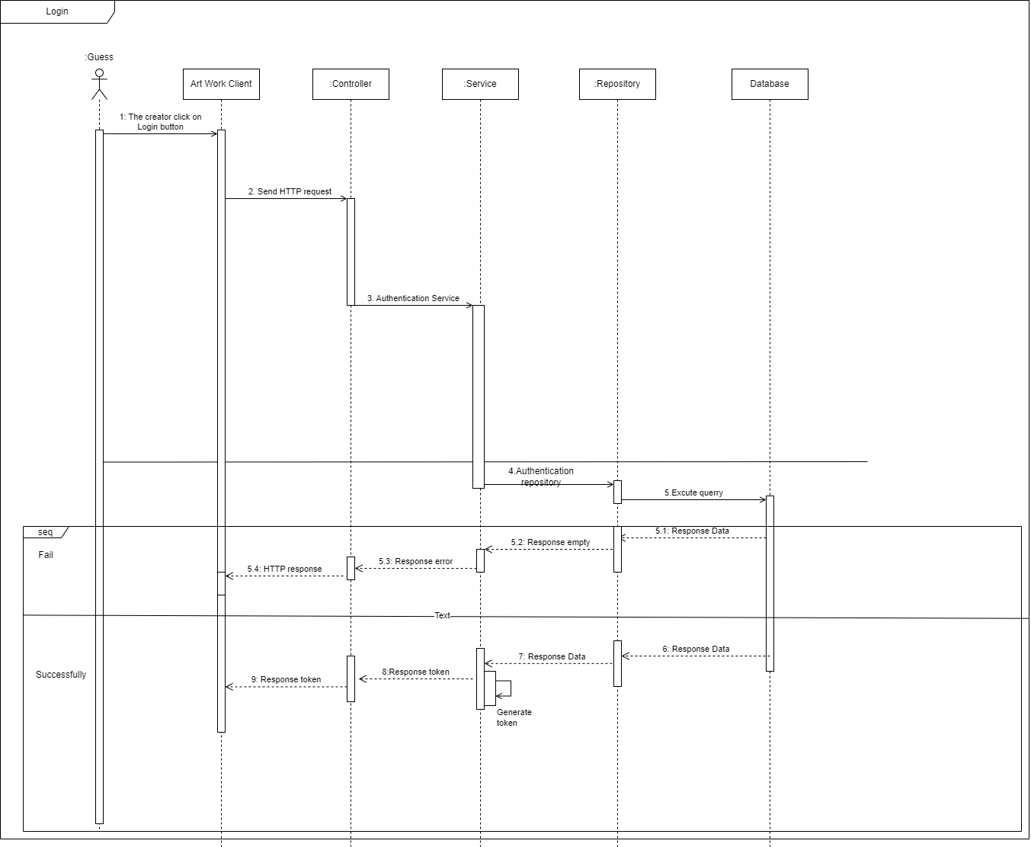Figure 3. Sequence Diagram for Login Progress.

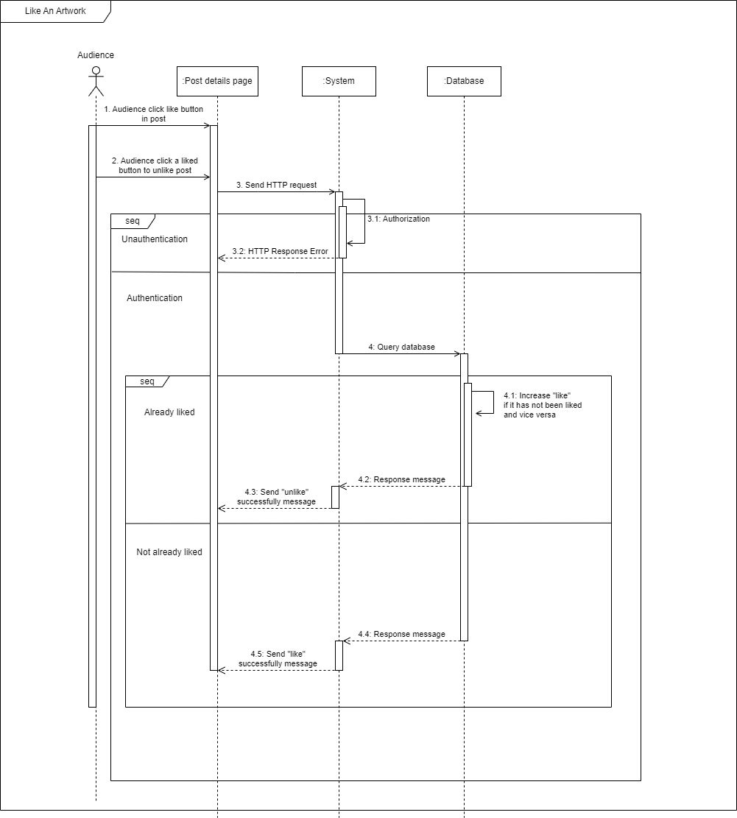

Figure 4. Sequence Diagram for Like an artwork Progress.

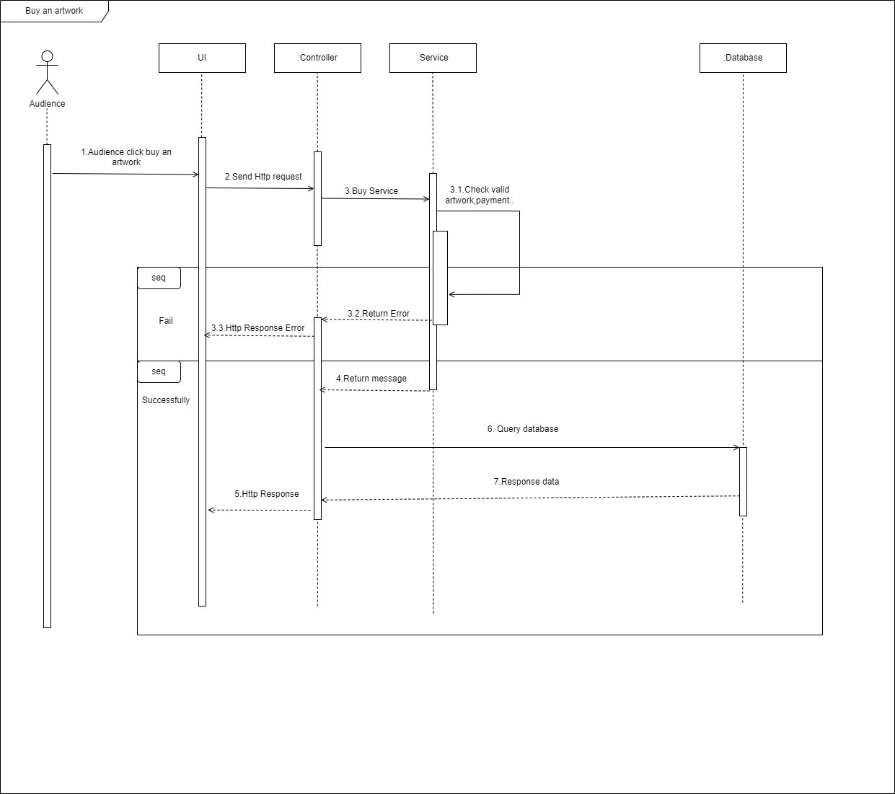

Figure 5. Sequence Diagram for Buy an artwork Progress.

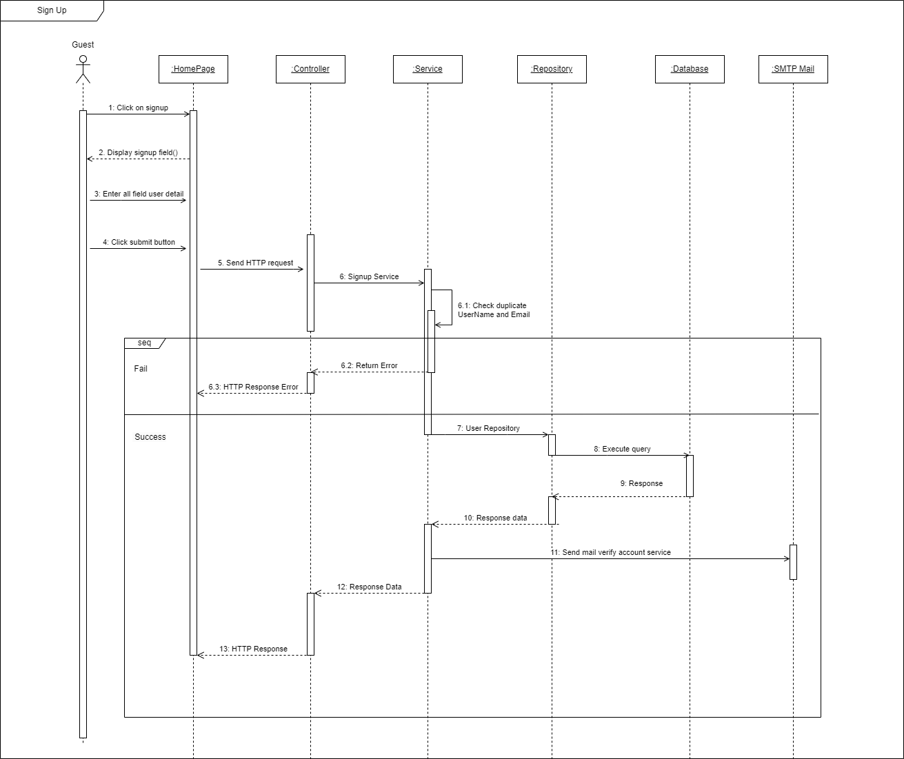

Figure 6. Sequence Diagram for Sign Up Progress.

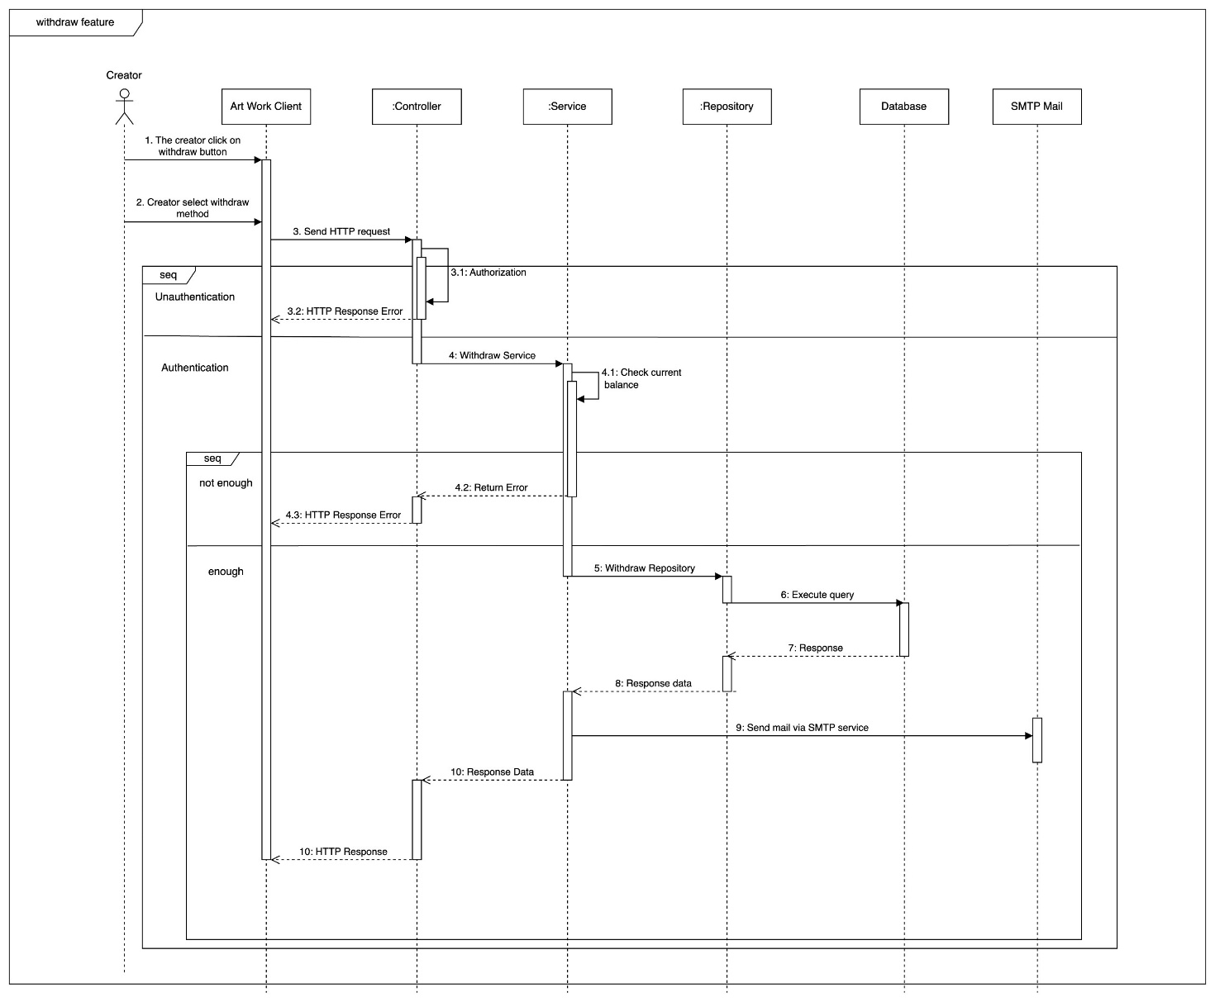

Figure 7. Sequence Diagram for Withdraw Progress.

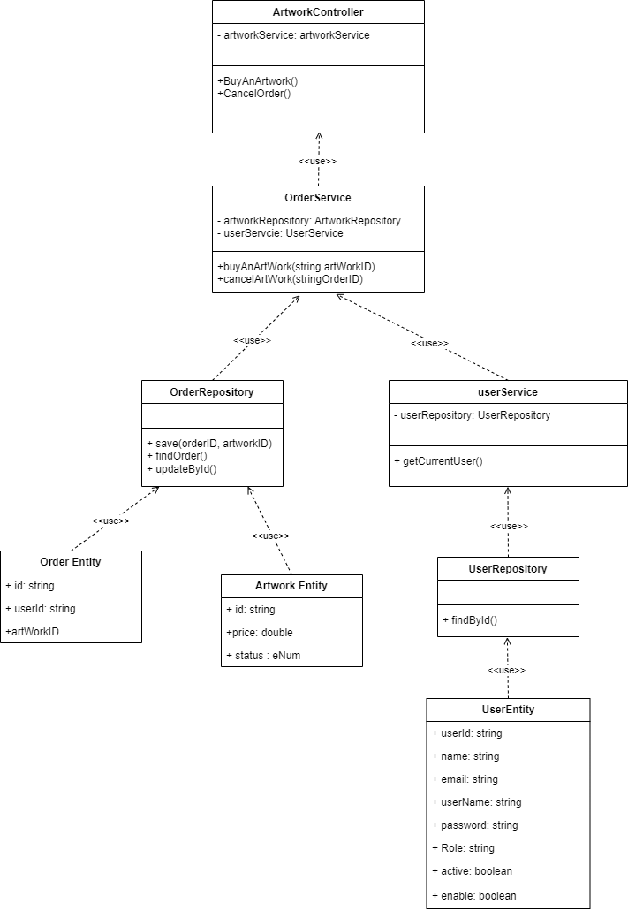

Figure 8. Class diagram buy an artwork.

Figure 9. Class diagram Login.

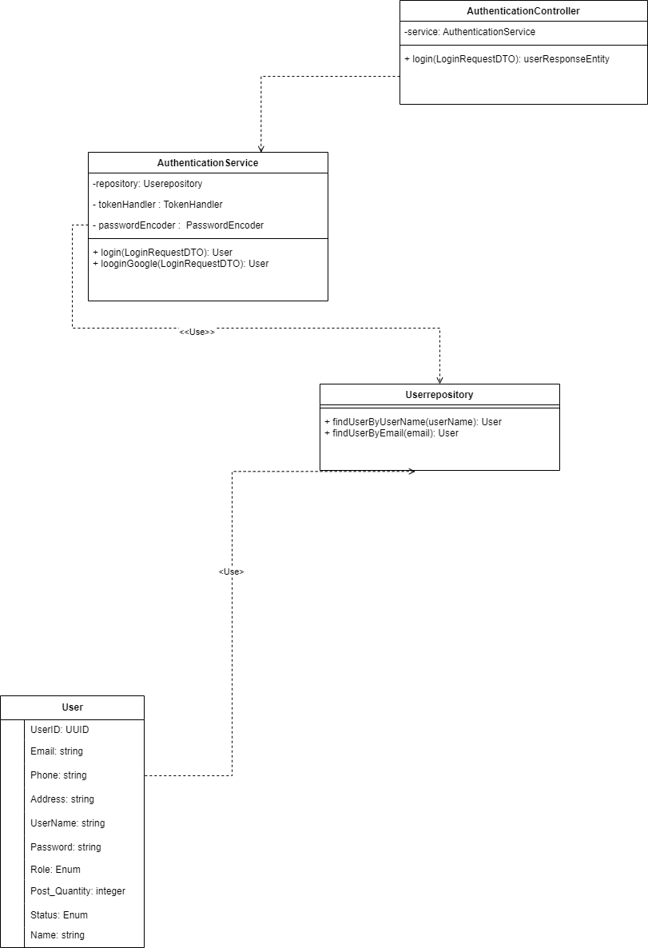

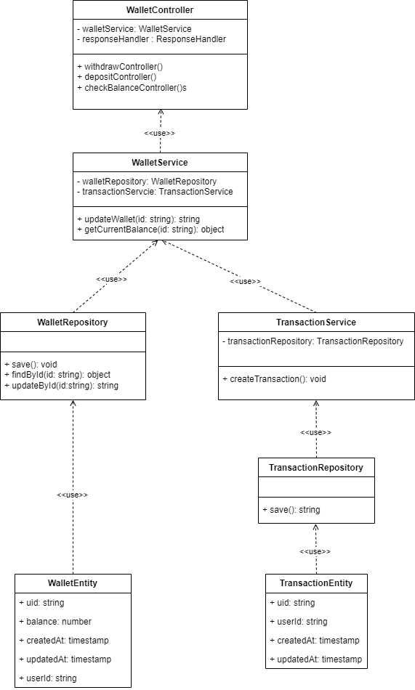 Figure 8. Class diagram withdraw

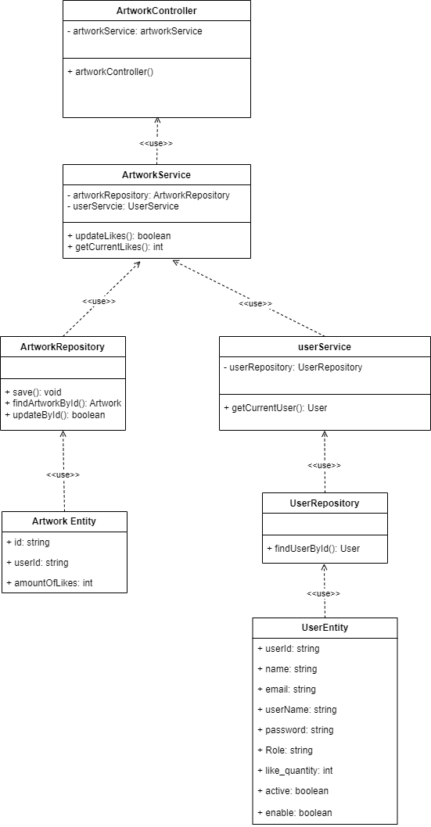 Figure 8. Class diagram Like an artwork

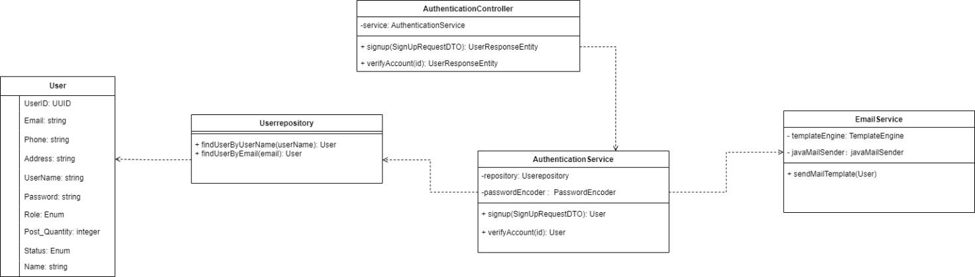

Figure 8. Class diagram sign up.